**Analysis Code**

**Statistical analyses in this study were conducted on Stata 17.0.**

**First, we used the following code to obtain such information as mean, median, standard deviation and 95% CI.**

* mean *variable*

For example:

mean ASTSR

Mean estimation Number of obs = 430

--------------------------------------------------------------

| Mean Std. err. [95% conf. interval]

-------------+------------------------------------------------

ASTSR | 3.227907 .0494818 3.13065 3.325164

--------------------------------------------------------------

* sum *variable*, detail

For example:

sum ASTSR, detail

A-ST-SR

-------------------------------------------------------------

Percentiles Smallest

1% 1 1

5% 2 1

10% 2 1 Obs 430

25% 3 1 Sum of wgt. 430

50% 3 Mean 3.227907

Largest Std. dev. 1.026076

75% 4 5

90% 5 5 Variance 1.052832

95% 5 5 Skewness .0002092

99% 5 5 Kurtosis 2.419767

**Second, we conducted Shapiro–Wilk tests to check the normality of data.**

* swilk *variable*

For example:

swilk ASTSR

Shapiro–Wilk W test for normal data

Variable | Obs W V z Prob>z

-------------+------------------------------------------------------

ASTSR | 430 0.99853 0.432 -2.004 0.97745

**Finally, we adopted mixed-effects models analyses to study the impact of rhyme, metaphor and antithesis in advertising slogan on Chinese consumers’ perception and compare their perception of English slogans and Chinese translations. Eye-tracking data were not normally distributed (*p*<.01), so we built Generalized linear mixed models (GLMMs) analyses on the data. We used the following code.**

****

* meglm variable fixedfactor || randomfactor:

For example:

meglm TTSA i.GroupSA || TTBackgroundSA:

Fitting fixed-effects model:

Iteration 0: log likelihood = -2216.7366

Iteration 1: log likelihood = -2216.7366

Refining starting values:

Grid node 0: log likelihood = -2217.9063

Fitting full model:

Iteration 0: log likelihood = -2217.9063 (not concave)

Iteration 1: log likelihood = -2217.0792 (not concave)

Iteration 2: log likelihood = -2216.6822

Iteration 3: log likelihood = -2216.5792

Iteration 4: log likelihood = -2216.578

Iteration 5: log likelihood = -2216.578

Mixed-effects GLM Number of obs = 684

Family: Gaussian

Link: Identity

Group variable: TTBackgroundSA Number of groups = 4

Obs per group:

min = 36

avg = 171.0

max = 372

Integration method: mvaghermite Integration pts. = 7

Wald chi2(1) = 2.73

Log likelihood = -2216.578 Prob > chi2 = 0.0985

--------------------------------------------------------------------------------

TTSA | Coefficient Std. err. z P>|z| [95% conf. interval]

---------------+----------------------------------------------------------------

1.GroupSA | .7812105 .4728999 1.65 0.099 -.1456562 1.708077

_cons | 13.76178 .3825712 35.97 0.000 13.01195 14.51161

---------------+----------------------------------------------------------------

TTBackgroundSA |

var(_cons)| .0825025 .1917288 .0008677 7.844885

---------------+----------------------------------------------------------------

var(e.TTSA)| 38.15357 2.066921 34.31013 42.42755

--------------------------------------------------------------------------------

LR test vs. linear model: chibar2(01) = 0.32 Prob >= chibar2 = 0.2867

**Subjective ratings were normally distributed (*p*>.05), so we built Linear mixed models (LMMs) analyses on the data. We used the following code.**

* mixed variable fixedfactor || randomfactor:

For example:

mixed TTSR i.GroupSR || TTBackgroundSR:

Performing EM optimization ...

Performing gradient-based optimization:

Iteration 0: log likelihood = -1270.7883

Iteration 1: log likelihood = -1270.6861

Iteration 2: log likelihood = -1270.6816

Iteration 3: log likelihood = -1270.6816

Computing standard errors ...

Mixed-effects ML regression Number of obs = 860

Group variable: TTBackgroundSR Number of groups = 4

Obs per group:

min = 50

avg = 215.0

max = 470

Wald chi2(1) = 11.84

Log likelihood = -1270.6816 Prob > chi2 = 0.0006

------------------------------------------------------------------------------

TTSR | Coefficient Std. err. z P>|z| [95% conf. interval]

-------------+----------------------------------------------------------------

1.GroupSR | -.2488372 .0723152 -3.44 0.001 -.3905724 -.107102

_cons | 3.272093 .0511346 63.99 0.000 3.171871 3.372315

------------------------------------------------------------------------------

------------------------------------------------------------------------------

Random-effects parameters | Estimate Std. err. [95% conf. interval]

-----------------------------+------------------------------------------------

TTBackgrou~R: Identity |

var(_cons) | 2.11e-10 1.24e-07 0 .

-----------------------------+------------------------------------------------

var(Residual) | 1.12434 .0542205 1.022938 1.235795

------------------------------------------------------------------------------

LR test vs. linear model: chibar2(01) = 0.00 Prob >= chibar2 = 1.0000

**We started with a simple model from the fixed effect and obtained the best model with the lowest BIC. We used the following code.**

**Model comparison analysis code:**

* estat ic

For example:

estat ic

Akaike's information criterion and Bayesian information criterion

-----------------------------------------------------------------------------

Model | N ll(null) ll(model) df AIC BIC

-------------+---------------------------------------------------------------

. | 684 . -2216.578 4 4441.156 4459.268

-----------------------------------------------------------------------------

Note: BIC uses N = number of observations. See [R] BIC note.

**We did model checking by examining the distribution of residuals. We used the following code.**

**Model checking analysis code:**

* predict fitted, xb
* predict residuals, res
* twoway scatter residuals fitted
* pnorm residuals

For example:

predict fitted, xb

predict residuals, res

twoway scatter residuals fitted

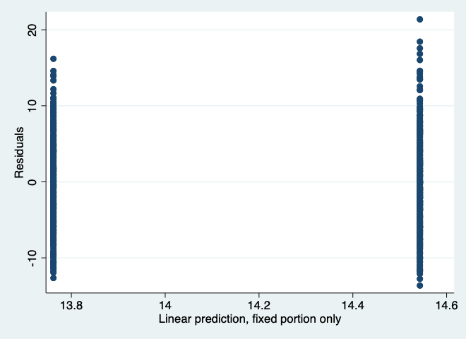

pnorm residuals

